|  |
| --- |
| **Lazy pixels**   |
| The Zom-B Terminator |
| **“Dawn of the Dead”** |
| Version 0.5  All work Copyright © 2020 by LAZY PIXELS.  All rights reserved. |
| **Romal George**  **Surya Narayana Pakalapati**  **Palak Arora**  **Shivangi Shandilya** |
|  |

|  |
| --- |
| August 14th 2020 |

**Table of Contents**

1. Game Overview
2. Game Play Mechanics
3. Camera
4. Controls
5. Interface Sketch
6. Menu and Screen Descriptions
7. Game World
8. Levels
9. Game Progression
10. Characters
11. Enemies
12. Items
13. Script
14. Scoring
15. Sound Index
16. Story Index
17. Design Notes
18. Future Features

**Version History**

Version 0.5

Final Build:

* An interactive graphical user interface is implemented, having different screen menus.
* Added game complete screen. The game end screen consists of three buttons, return to main menu or redirect towards any of the three levels.
* All the graphics and functionalities have been implemented including Level-1,2 and3.
* All the levels were completed with MainMenu Screen.

1. **Game Overview**

The story starts with an evil gene scientist Jojo hated by people of the Pixel City and on the other hand there was a good scientist Bing whose inventions were always appreciated by others. Seeking revenge from public, the evil guy invents a virus called “ZOM-B” converting people into Zombies and kidnaps the good scientist. The main character is a Robot which is one of the inventions of the good scientist, who will save the city from zombies and rescue his owner in order to create an anti-virus.

1. **Game Play Mechanics**

* Move front and back
* Shoot
* Jump
* Slide

1. **Camera**

Side Scroller (Side View Camera)



1. **Controls**

|  |  |
| --- | --- |
|  | Move left |
|  | slide |
|  | For jump |
|  | To shoot |
| Framed Print - Computer Key Art - Letter D (Picture Poster ... | Move right |

1. **Interface Sketch**

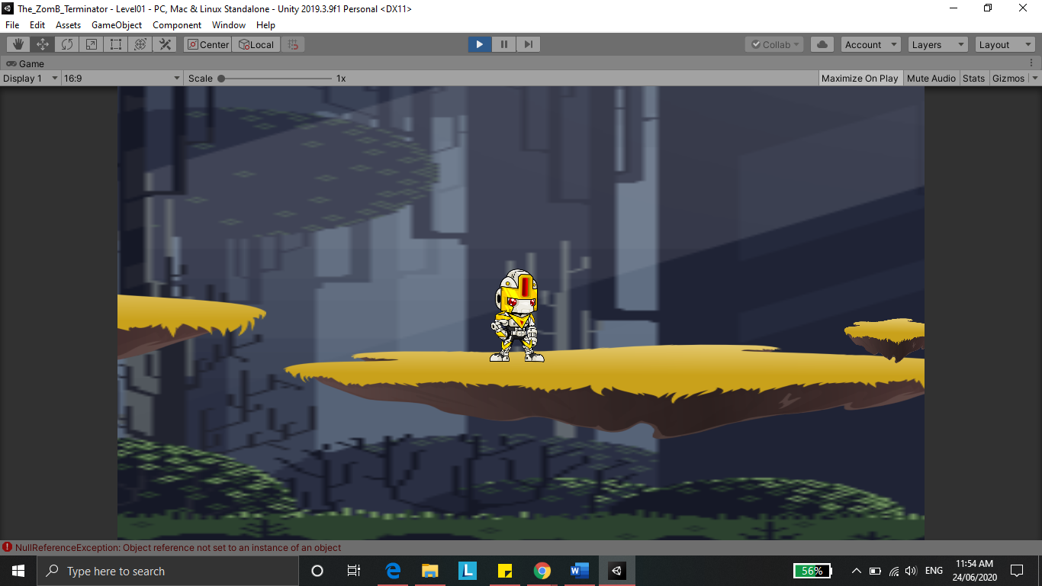

1. **Menu and Screen Descriptions**

**Menu Screen:**

* Play Button – Starts the game
* Exit Button – To exit the game

**Play Mode:**

* High Score – Shows the highest score the player has gained
* Time – Shows the time taken to complete a level.
* Health Description – Shows the health the player has.

1. **Game World**

In “The Zom-B Terminator” the main character kills the enemies, collect some valuable items which will maintain the game score, escape from some traps, perform some mechanics

1. **Levels**

* Level 1 – The beginning of the dead

In Level 1 the player will have to cross the city area which is filled with zombies. The Player’s health will be reduced if come in contact with the zombies. He will have to shoot the zombies in order to kill them.

* Level 2 – Going to Lab

In Level 2 the player will explore the outskirt area of the city to find the lab of Dr. JOJO, where he has kept Mr. BING. The terminator will have to fight the zombies and other obstacles such as blades or poison spills in between the path to the lab. He can dodge from other obstacles by sliding or jumping.

* Level 3 – Rescuing Mr. BING

In the last level the player is going to fight with the main villain of the game which is a robot made by Dr. JOJO. The main enemy is going to have multiple powers such as shooting fire balls and attacking the player. The player will have to utilize all the skills learned in previous levels.

1. **Game Progression**

In “The Zom-B Terminator” the main character kills the enemies, collect some valuable items which will maintain the game score, escape from some traps, perform some mechanics like attacking.

1. **Characters**

* Dr. JOJO : The evil Scientist



* Mr. BING: The good Scientist

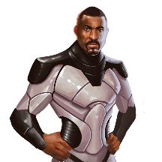

* Terminator: The Robot

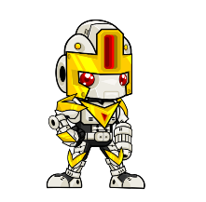

* Zombies : Soldiers of Dr.JOJO.

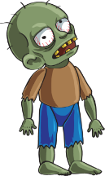 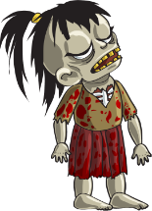

* Robot of Dr. JOJO.



1. **Enemies**

* Zombies: Enemies moving in a computer specified path and boss zombies
* The evil Scientist’s Robot: Final Enemy

1. **Items**

* Collectable Coins



* Saws



* Lightening



1. **Script**

The hints and tips to win the levels will be provided by the people of the Pixel city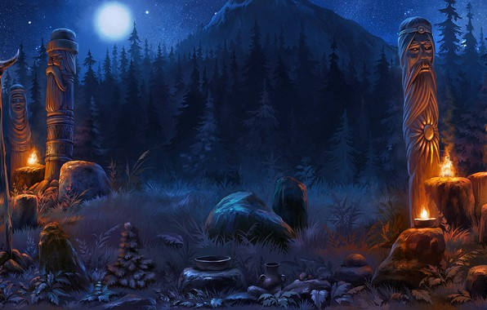

to the Terminator (i.e. and escape from the dropping poison, collecting as much coins as possible, and to reach at the end.

1. A picture containing toy, drawing

   Description automatically generated**Scoring**

Collect coins each of score : 10.

1. **Sound Index**

* Background Music.
* Attack Sound effect.

1. **Story Index**

The aim of this game is to for the player (Robot) to reach the Good Scientist while Zombies try to attack the Robot on its way. After Killing each zombie boss, the Robot moves to next level, collecting the coins, getting scored for each coin collected and finally on the level to kill the Evil Scientist.

1. **Design Notes**

* Obstacles such as lightening and blades in the path should occur as expected.
* Validating Zombies placement at appropriate places.
* Planning the platform surface.
* Keep track of appropriate ending of a level.

1. **Future Features**

* Weapon Enhancement.
* Vitality Attribute added to final build.
* Bonus Points Enhancements for longer hours of engagement in game.
* Enemies (Evil Doctor and Zombies) to have more power meters.